RESPIRATORY/RENAL SYSTEM
Choose the correct answer
- A 46-years-old man complained of fever, chronic cough with purulent sputum for 3 weeks. MRI imaging showed bilateral basal lung lesions with destruction of the lung tissues. The diagnosis of this condition is…..
- Lung abscess. D. Lobar pneumonia.
- Bronchiectasis. E. Tuberculosis.
- Bronchopneumonia.
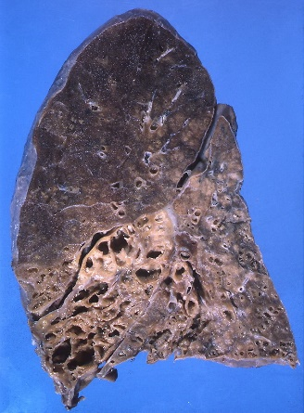
………………………………………………………………………………………………
- A 23-years-old female suffered from nasal discharges and obstruction for 2 weeks. Clinical examination showed a small soft tissue mass in the Rt nasal cavity. A biopsy from the nasal cavity showed chronic inflammatory cells, Mikulize cells and Russell bodies. What is the diagnosis?
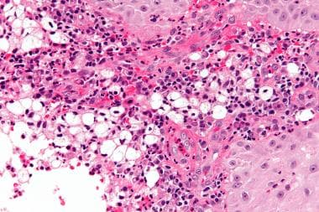
- Nasal polyp. D. Diphtheria.
- Rhinoscleroma. E. Papilloma.
- Chronic nonspecific rhinitis.
……………………………………………………………………………
- A 12-years old child complained of cough, dyspnea and weight loos for 3 weeks. MRI imaging showed a Lt Lung small lesion at the lower margin of the upper lobe with enlarged hilar lymph node. A biopsy from the lung focus showed Langhans’s giant cell epithelioid granuloma. What is the diagnosis?
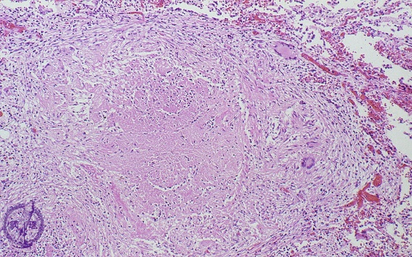
- Lobar pneumonia. D. Pulmonary tuberculosis.
- Bronchopneumonia. E. Lung abscess.
- Bronchiectasis.
………………………………………………………………………………
- A 71-years-old man complained of cough and hemoptysis for 2 weeks. He has a long history of cigarette smoking. MRI imaging showed Rt lung mass about 4x5cm, infiltrating the main bronchus. What is the possible diagnosis?
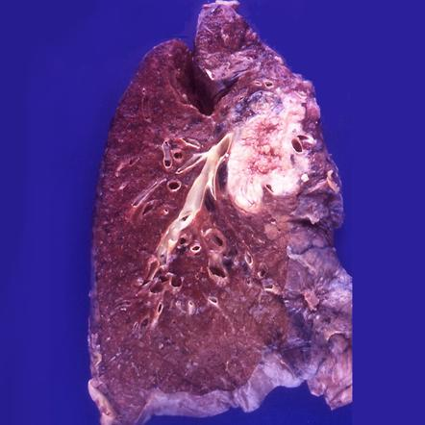
- Lung abscess. D. Bronchiectasis.
- Bronchopneumonia. E. Emphysema.
- Bronchogenic carcinoma.
………………………………………………………………………….
- A 46-years-old man suffered from chronic dry cough, dyspnea and cyanosis. A clinical examination revealed a barrel-shaped chest with central cyanosis. A biopsy from the lung showed distended lung alveoli with destruction of the alveolar septa. What is the diagnosis?
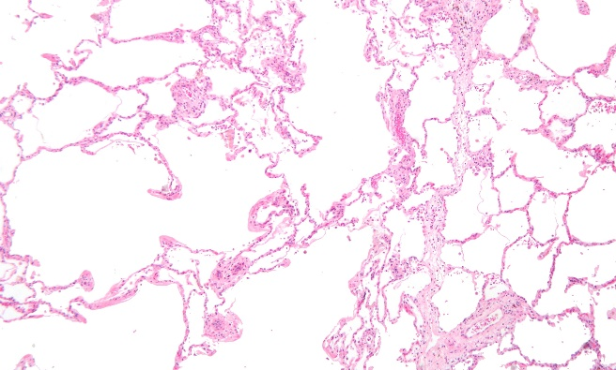
- Emphysema. D. Bronchogenic carcinoma.
- Bronchopneumonia. E. Lobar pneumonia.
- Chronic bronchitis.
……………………………………………………………………………
- A 64-years old man complained of Lt Loin pain and hematuria for 7 days. MRI imaging showed a round well defined renal mass about 5x5cm, firm, yellow, with area of necrosis and hemorrhage. The mass infiltrated the renal capsule. What is the diagnosis?
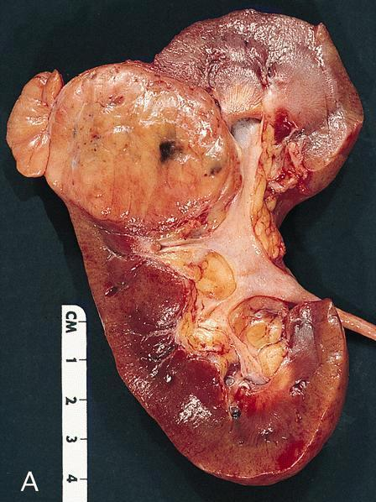
- Renal stone. D. Renal cell carcinoma.
- Chronic pyelonephritis. E. Chronic glomerulonephritis.
- Renal hydronephrosis.
……………………………………………………………………………
- A 56-years-old-man complained of hematuria and suprapubic pain for 3 months. A cystoscopy showed a urinary bladder papillary mass about 2x3cm.
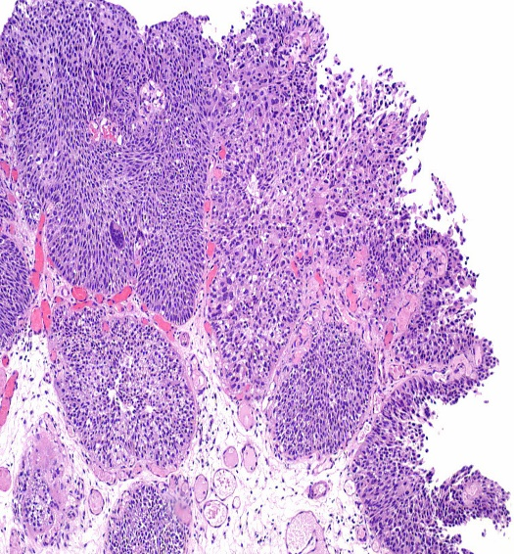
- Bilharzial cystitis. D. Urothelial carcinoma.
- Cystitis cystica. E. Cystitis glandularis.
- Squamous cell carcinoma.
…………………………………………………………………..

